Sprint - 2

|  |  |
| --- | --- |
| Team ID | PNT2022TMID11712 |
| Project Name | Smart Fashion Recommender Application |

Creating UI for Admin Panel Admin Login

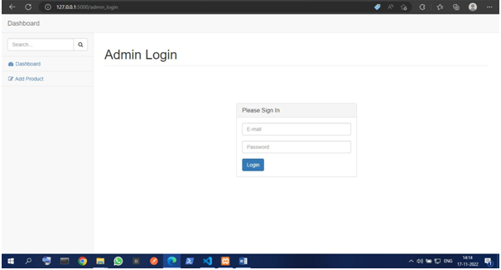

Admin Panel

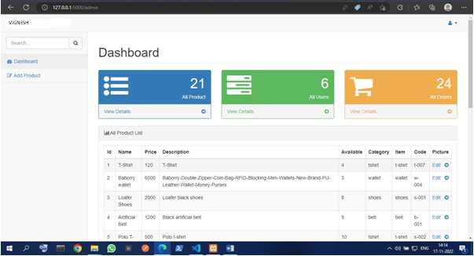

Creating database connection for admin panel

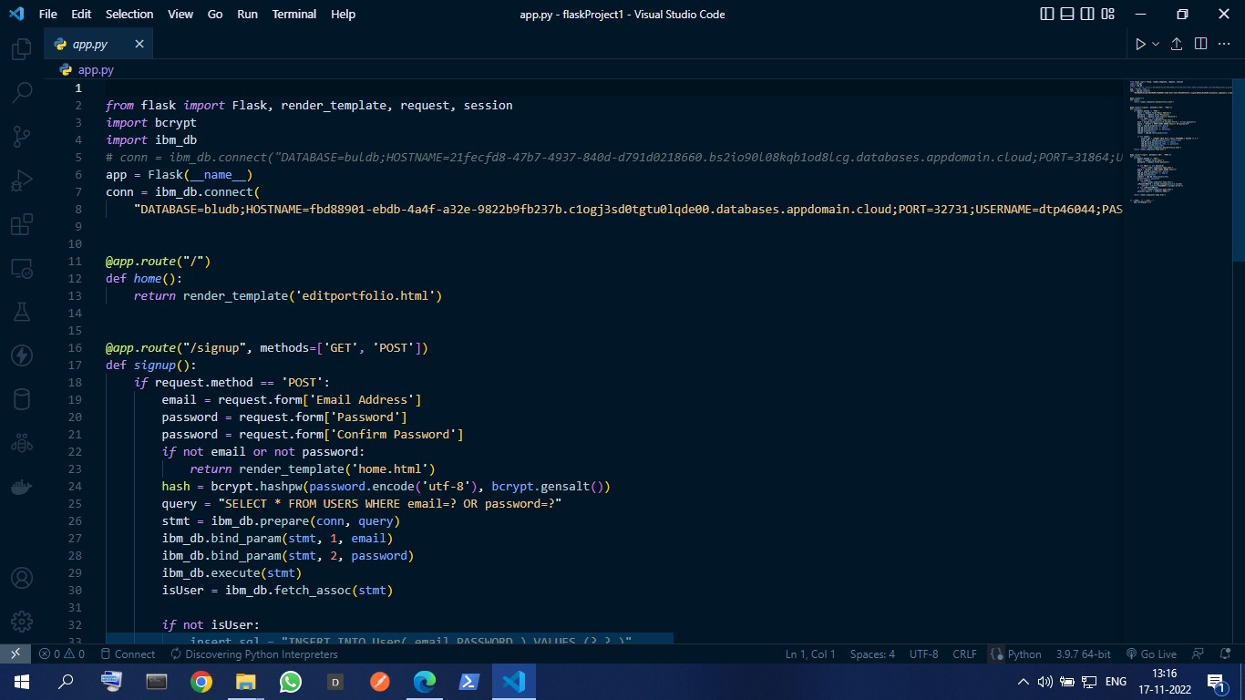

Completing the Admin panel Add Product

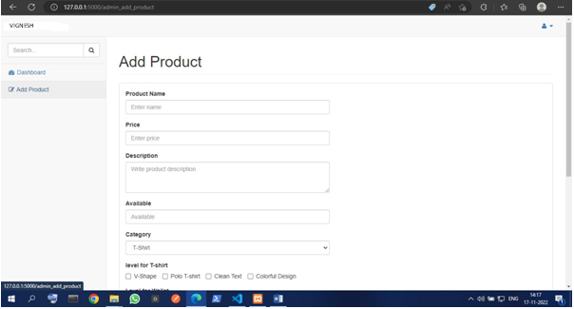

Dashboard

